Ben
Weekly Relays User Guide
TOPICS LEGEND
 |  | WEEKLY RELAYS |  | Jan. 5, 2017
YOUR DEPARTMENT NEWS |  |  | UTMB NEWS
OSSA  Dr. Lisa Cain has been honored as the Keynote Speaker for the Dr. Martin Luther King Jr. Service Award Ceremony and Luncheon to be held Friday, January 13th at 11:30 AM in the Levin Hall Dining Room. Reservations can be made at events.oua@utmb.edu or by calling (409) 747-6735.  Frontera de Salud is back from their new Medical Mission Trip and their new Holiday effort, Santa’s Toy Stop! After 18 years of serving the Lower Rio Grande Valley, Frontera de Salud adopted Presidio County, Big Bend Area as the site of their bi-annual medical mission trip, December 16 – 22, 2016. Thanks to the 15 pioneer students from all schools who have volunteered: Edward Strecker, Guillermo Foncerrada Ortega, Laura Fitzgerald, Trevor Silva, Milena Lobaina, Alexandria, Smith, Craig Thomas, Samuel Vega, Mauli Dalal, Erik Sanchez, Daniela Vazquez Rodriguez, Jennifer Espinales, Paola Bustillos, Thiennga Vo, William Hertzing, Jesse Wu. Faculty Advisor and Executive Director: Norma A. Pérez, MD, DrPH.  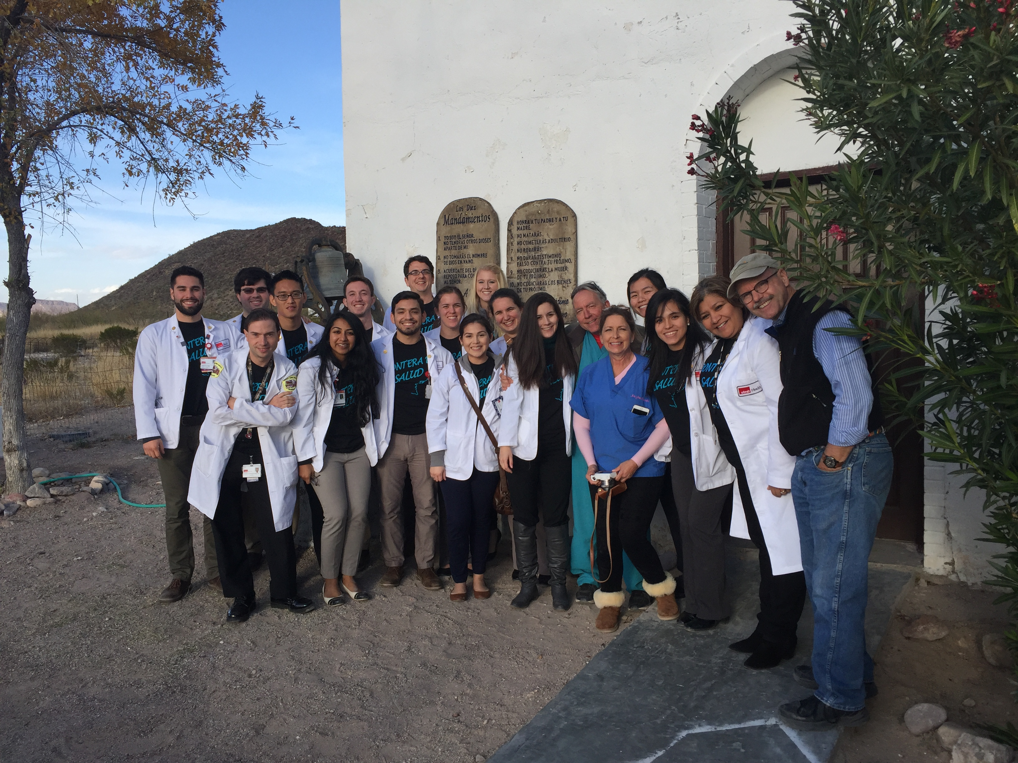  ORME Austin  Rising Fourth Year Class Meeting: January 31, 12:30 to 2:30 PM, led by Dr. Julie McKee  OEA  We are now accepting minimester proposals for 2017. The minimester will be held August 28 through September 8. The deadline to submit a course proposal is January 27. Proposals may be submitted at https://www.utmb.edu/meded/minimester/default.asp |  |  | Information on John Sealy Hospital fire recovery:  Following the fire in a non-patient care area at John Sealy Hospital on Jan. 4, a website has been created to keep employees informed about recovery efforts in the coming days and weeks. The website address is http://www.utmb.edu/recovery/.  Showcasing our UTMB Wonders:  Starting Jan. 16, UTMB will launch a new advertising campaign to highlight the many “Wonders” happening across our campuses and in our clinics. This UTMB Wonders campaign—through a combination of broadcast TV and radio spots and digital advertising—will help us share UTMB’s message and build our brand in a region where the health care landscape has become increasingly competitive in recent years. Be on the lookout in next week’s Relay Notes for a website link that will offer UTMB employees the chance to see these new brand-building advertisements before anyone else.  UTMB awarded $10 million from CDC to fight vector-borne diseases  To help stop the spread of diseases carried by arthropod vectors such as mosquitoes and ticks, the Centers for Disease Control (CDC) and Prevention awarded $10 million to UTMB to establish the Western Gulf Center of Excellence for Vector-Borne Diseases. The center’s work will protect public health in the region, the nation and beyond. The award is a part of the CDC’s funding provided under the Zika Response and Preparedness Appropriations Act of 2016. For more information, please visit https://www.utmb.edu/newsroom/article11392.aspx.  Reminder—Best Care Lunch & Learn series starts Jan. 18:  Would you like to learn more about the many initiatives underway to achieve Best Care at UTMB? Join UTMB Health System executive leadership for a series of Lunch & Learns that will provide an in-depth look at our major areas of focus for improvement, as well as the areas in which we are outperforming many of our academic medical center peers. For details, visit the Best Care website at http://intranet.utmb.edu/best-care/default.asp.  Update home, mailing addresses for tax forms:  With preparation underway on year-end tax forms, Payroll Services is asking that employees review, and update if necessary, their home addresses in the PeopleSoft HCM system. Click on Employee Self Service and follow the path of: Personal Information>Home and Mailing Address. All updates should be completed on or before Jan. 13.
TOPICS  LEGEND | PATIENT CARE EDUCATION & RESEARCH INSTITUTIONAL SUPPORT CMC
AROUND UTMB (Use the legend above to quickly find items of interest to your team)
UTMB NEWS (continued)  Reminder—All UTMB vendors must wear a vendor/visitor ID badge:  UTMB faculty and staff who interact with vendor representatives are responsible for ensuring that vendors follow the proper procedures. According to UTMB IHOP Policy 09.07.02, industry vendors may not be on campus without prior permission from authorized personnel. In addition, vendors must:  - have an appointment with authorized personnel before arriving on campus;  - have obtained approval from the authorizing department;  - have obtained and wear a UTMB vendor/visitor ID badge; and  - be accompanied by authorized UTMB staff when in clinical secured areas.  Steps for vendor registration and the full policy regarding UTMB Vendor Representative Procedures can be found at https://www.utmb.edu/policies_and_procedures/IHOP/Supporting_Documents/IHOP%20-%2009.07.02%20-%20Vendor%20Visitation%20UTMB%20Clinical%20Enterprise%20(Vendor%20Procedures).pdf.  Protecting PHI:  Please remember that text messaging for patient care orders is not an acceptable practice at UTMB. Texting is NOT a secure method of transmitting PHI. Additionally, it is important to ensure the closure of communications among the care team regarding patient care; although the use of secured UTMB email to communicate patient information is acceptable, please use Epic as the first priority.  Masking requirements for health care workers:  Influenza (flu) and respiratory syncytial virus (RSV) seasons have begun. Masking requirements for health care workers who have not been vaccinated for influenza began Jan. 2. Details at https://intranet.utmb.edu/healthsystem/default.asp. |  |  | ITS seeking applicants for clinical trials/multidisciplinary translational teams funding:  UTMB’s Institute for Translational Sciences is soliciting applications for pilot funding to support clinical trials in Precision Medicine/Outcomes Research and New Multidisciplinary Translational Teams. In supporting clinical trials in Precision Medicine/Outcomes Research, the institute’s intention is to facilitate use of large datasets, -omics technologies and other innovative methods to:  - identify new diagnostics and targets for prevention and treatment,  - advance pharmacological studies, and  - accelerate development of precision approaches.  Multidisciplinary Translational Teams (MTTs) are diverse groups of researchers addressing a variety of important health issues. While each MTT is unique, they have common elements, including a focus on translational research, and the fact that they are composed of both senior and junior level investigators from multiple disciplines or departments.  To be considered for funding, applications must be received by 5 p.m. on Feb. 10 and must follow all instructions in the RFAs, available at: Clinical Trials in Precision Medicine/Outcomes Research RFA or Establishing a Multidisciplinary Translational Team RFA.
DID YOU KNOW?
IHOP isn’t just a convenient place for pancakes, but also where UTMB faculty, staff and students look to answer all questions regarding institutional policies. The Institutional Handbook of Operating Procedures, or IHOP, is the official document containing approximately 560 policies, procedures and their supporting documents for governance of the institution. The policies cover questions you may have regarding all areas of your involvement with UTMB, which is why there is a search feature to locate the specific policy addressing your question quickly. The IHOP website is located at https://www.utmb.edu/policies_and_procedures/default.aspx.

